**CSV files**

* Comma separated values
* It is used for storing data at database or spreadsheet
* Each line of file is called as record
* Each record consist of fields separated by commas(,) delimiter other delimiters such as tab (/t) semicolon (;) colon (:) are also used
* Any language that can work with text file input and string manipulation such as python, HTML can also use csv files.

READ THE CSV FILE

1)Data in the notepad which was saved with extension (.csv)

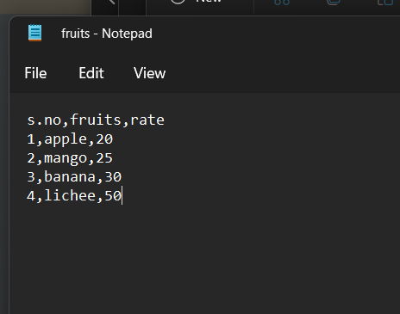

The data are noted in the note pad and separated by the comma (,) delimiter. Where each field is assigned with the data and the file is saved with the extension (.csv).

2)The code to convert it to the excel sheet

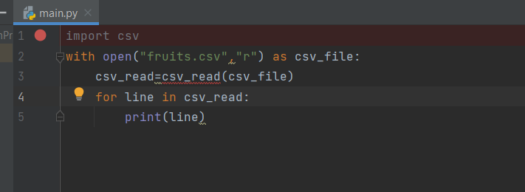

We are importing the csv file. With open we are opening the file under read mode “r” as csv file.New variable is introduced csv_read to call csv file . To iterate the file line by line for loop is used and the line is printed.

3) The output in the excel sheet

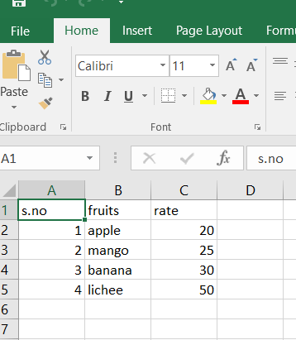

WRITE THE CSV FILE

1)Data in the notepad which was saved with extension (.csv)

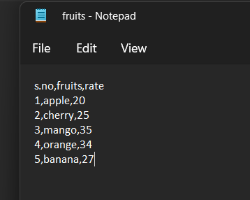

The data are noted in the note pad and separated by the comma (,) delimiter. Where each field is assigned with the data and the file is saved with the extension (.csv).

2)Code to convert and write in excel sheet and changing the delimiters

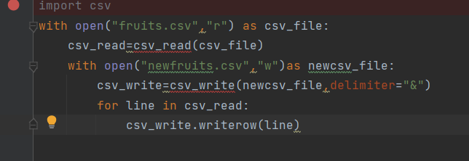

We are importing the csv file. With open we are opening the file under read mode “r” as csv file. New variable is introduced csv_read to call csv file. With open we are opening a new file in write mode “w”, whenever we open a file in write mode there it will create a new file. We are declaring csv_write for writing data in the file in the newcsv_file and we can also change the demiliter now after writing the file we will iterate by using for loop .

3)The output in excel sheet with change in delimiter

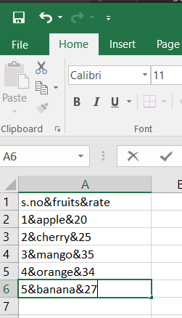

In the csv file the comma (,) will only be separating each fields since we assigned delimiter as & all the datas will be in the same field.

**PLOTS**

* Plot is the series of connecting the sequence events by some connectors.
* One of the most popular plotting library in python is matplotlib.

**Matplotlib** – Data visualization package

* Mat – mathematics
* Plot – chart
* Lib- library

**Types of plot**

* **Linechart**
* Line chart is used to describe the relation between two axis (x,y) .
* It is created by using series of several points connected by a straight line.

1. The code for the line chart

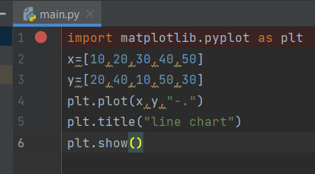

import matplotlib.pyplot as plt and assigning the x and y values and plotting the value in graph and plt.title is used to give the title for the chart and plt.show() is used

to display the chart

1. The output for the line chart

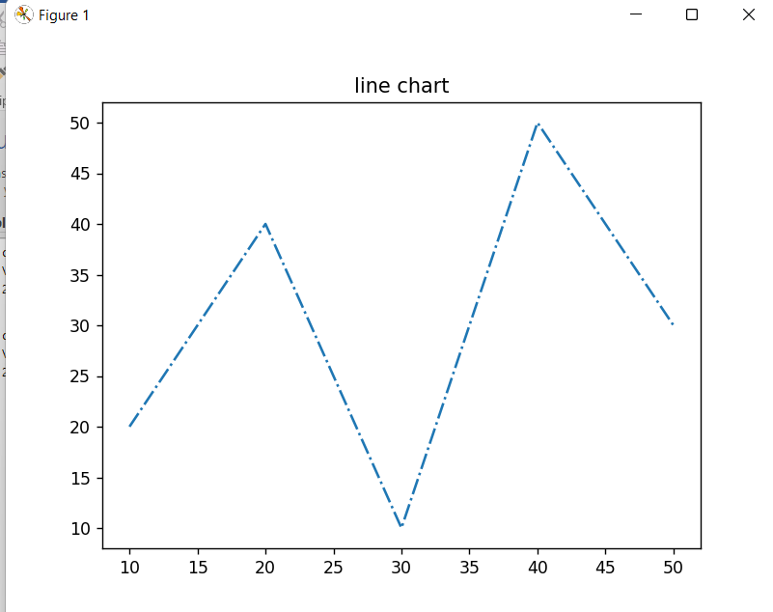

* **Bar Graph**
* It is used to graphical display of data using bars of different size.
* Different set of data among different groups are compared.
* All the bar will have same base.

1. The code for barchart

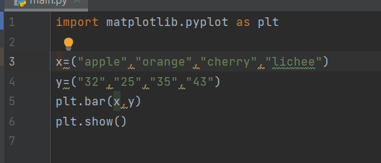

We will import matplotlib.pyplot as plt and assign the values for x-axis and y-axis. By using bar function to represent the bar graph and plt.show will draw the graph for the code that we have written.

1. The output for the bar graph

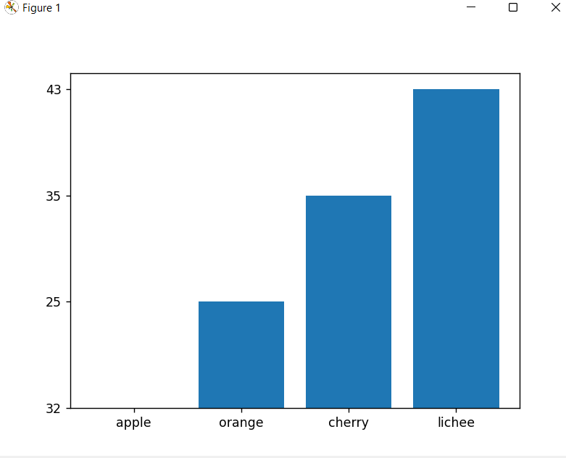

* **Pie plot**
* Pie chart is circular graphical representation.
* It is a statistical plot that can display only one series of data.
* Each slice represents the data
* The slice of pies are called wedges.

1. The code for the pie plot

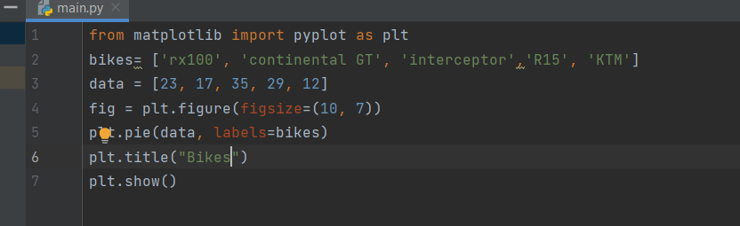

In the pie plot we are importing the libraries and creating the data set , then we are creating the plot and assigning the size of the figure . plt.title is used to set the title in the output and then the output is being displayed.

1. The output of pie plot

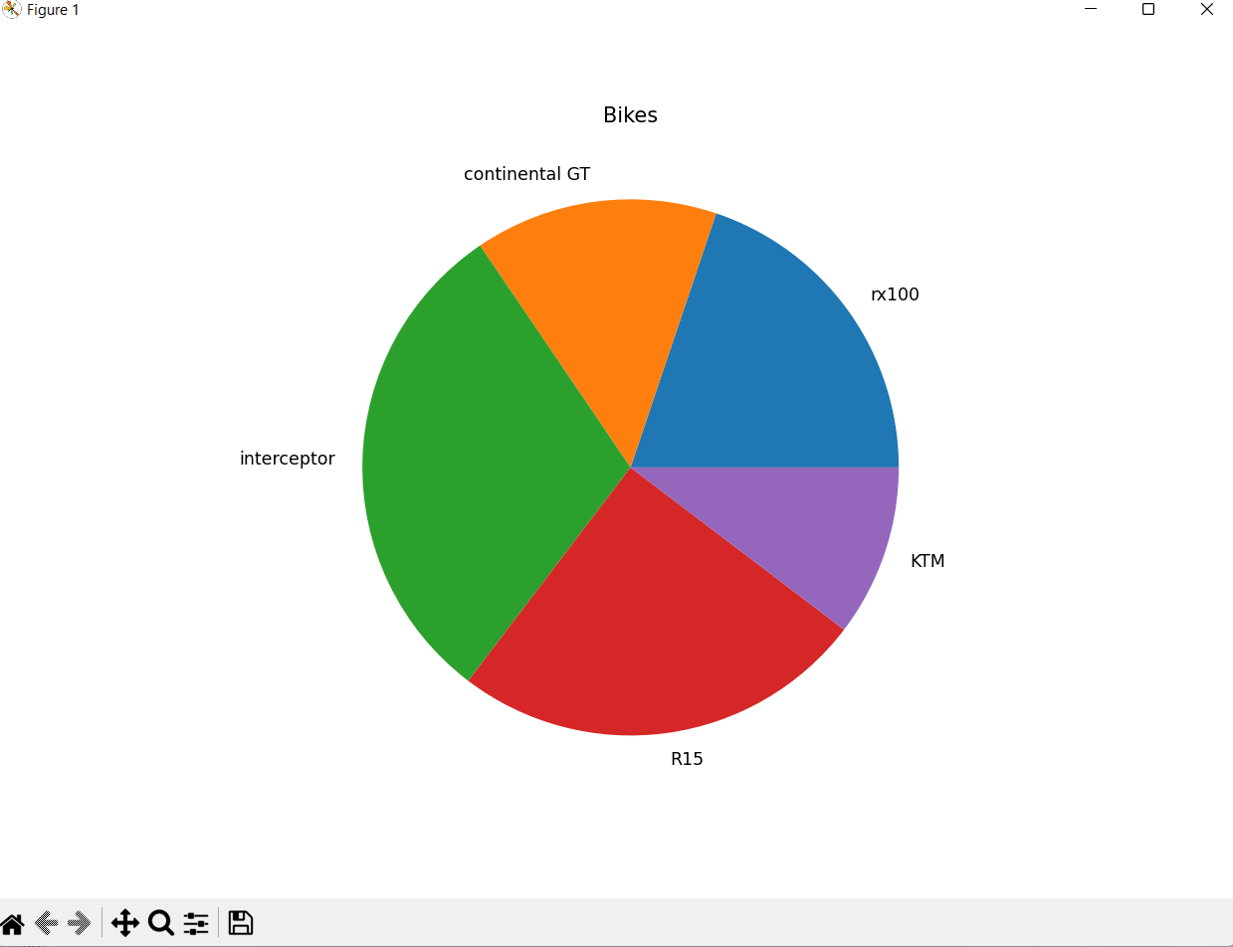

* **Scatter plot**
* It is used to represent the relation between the two variables of the data set.(pair of continuous variables)
* The data points are represented on the one-dimensional plane or Cartesian plane.
* Scatter plots can also be known as scatter chart, scatter graph or scatter gram.

1. The code for scatter plot

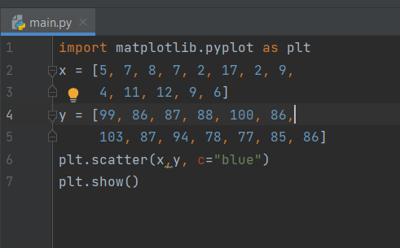

In the scatter plot, we are importing package and assigning the values for x-axis and y-axis and the scatter function is used to build a scatter plot and show function is used to display the graph.

1. The output for the scatter plot

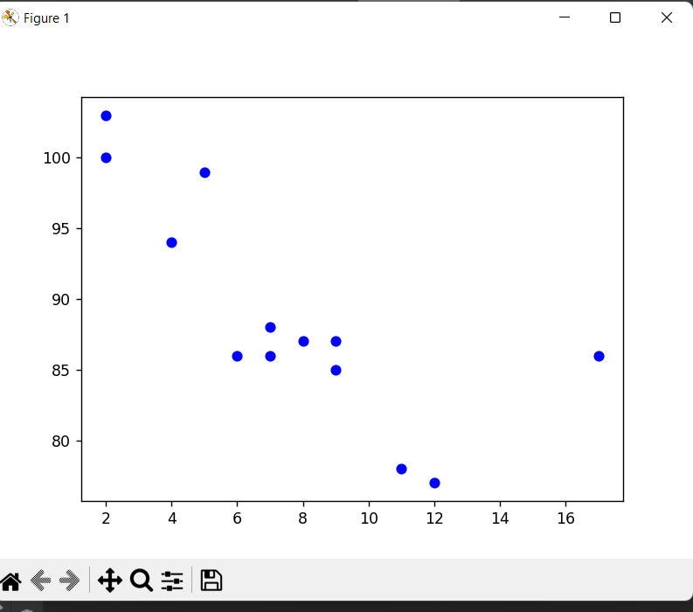

**RANDOM**:

* Random module is a set of functions that used to generate or manipulate random numbers.
* In random() float numbers are generated between (0.0-1.0).
* Random functions is used in games ,lotteries, lucky draws and password generators.

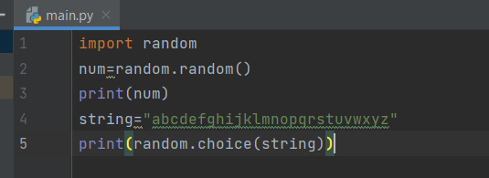

This code generates random numbers whenever the code is executed. Every time the code is executed there is new output.

Output1

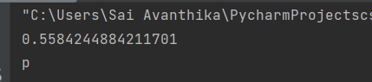

Output2

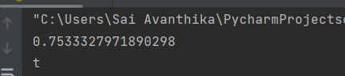

Output3

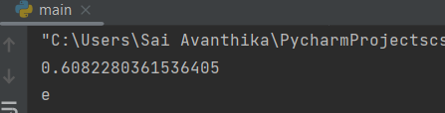

Output4

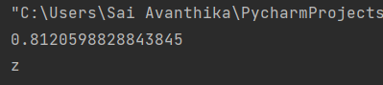

* **choice()**
* The choice() function defined in the function module to create random number.
* The created list will pass an argument to the choice() function.

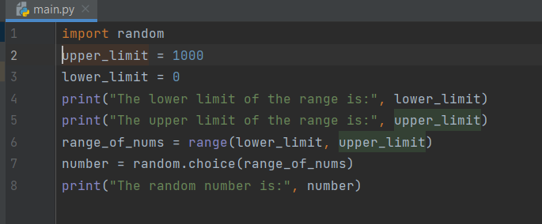

Output1

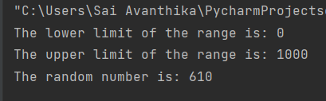

The random number is 610

Output2

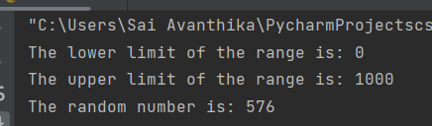

The random number is 576

* **radint()**
* To create random number in range we use randint() function.
* The lower and upper limit will be taken as range.
* The newly generated number can be equal to upper or lower limit.

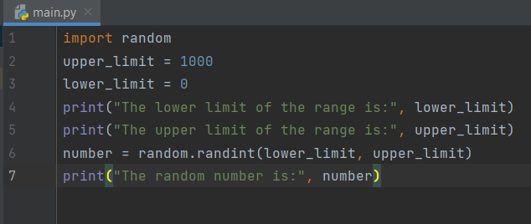

Output1

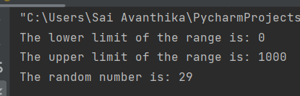

Output2

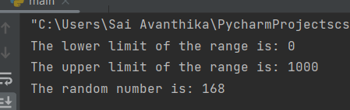

* **rand()**
* rand() function creates an array of specific shapes.
* It will the array with random numbers.

1)The code for rand()

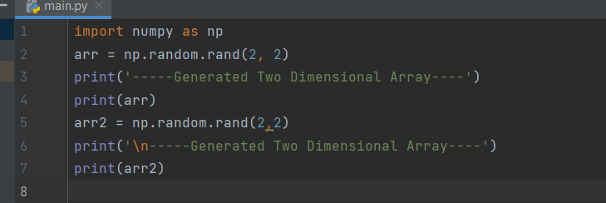

The numpy is imported as np and using rand() function the size of the array .The array will be generated.

2)The output executed from the code

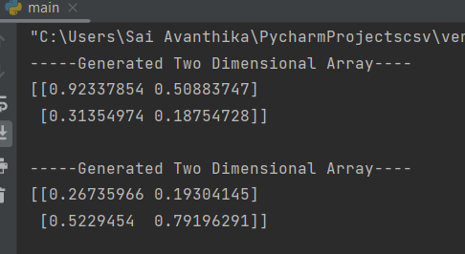

**NUMPY**

* Numpy performs mathematical operations on array using python package.
* Numpy is a module , it stands for “numerical python”.
* The numpy works in the domain of linear algebra , fourier transform and matrices.

## Access Array Elements

* Array indexing is the same as accessing an array element.
* You can access an array element by referring to its index number.
* The indexes in NumPy arrays start with 0, meaning that the first element has index 0, and the second has index 1 etc.

1. The code for accessing the array element

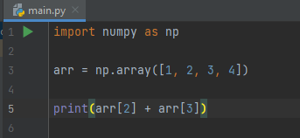

1. The output

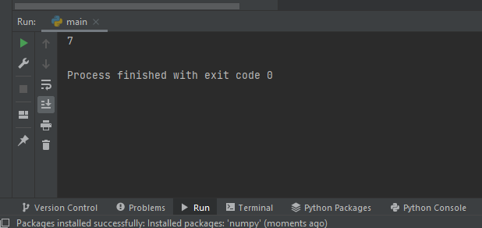

* **Slicing arrays**
* Slicing in python means taking elements from one given index to another given index.
* We pass slice instead of index like this: [*start*:*end*].
* We can also define the step, like this: [*start*:*end*:*step*].
* If we don't pass start its considered 0
* If we don't pass end its considered length of array in that dimension
* If we don't pass step its considered 1

1. The code for slicing the array

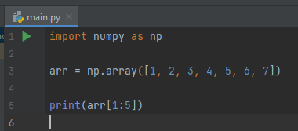

1. The output

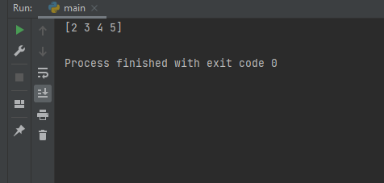

* **Split Into Arrays**

## The return value of the array_split() method is an array containing each of the split as an array.

## If you split an array into 3 arrays, you can access them from the result just like any array element:

## The code for splitting the element.

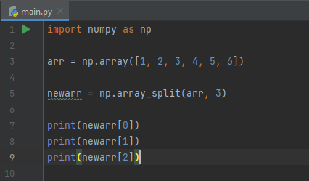

2)The output

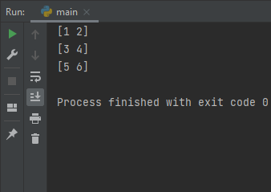

* **Creating the Filter Array**

In the example above we hard-coded the True and False values, but the common use is to create a filter array based on conditions.

1. The code for creating the filter array

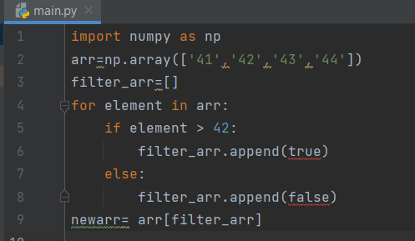

The numpy is imported and array is created using filter_arr empty list is created. For element is used to go through each element in array.by using if else statement ,if the element is higher than 42,set the value to True, otherwise false.

1. The output

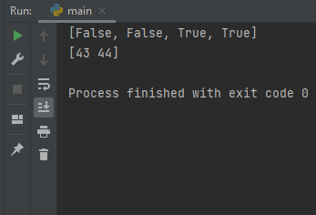

**DIMENSIONS**

* Dimension is used to measure the size of an object.
* Types of dimension
* One dimension
* Two dimension
* Three dimension
* **One dimension**

A one dimensional object has single measurement.

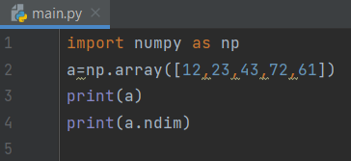

The numpy is imported as np. Array value is assigned as “a” .The “a” is printed and the dimension of array if found using np.ndim() function.

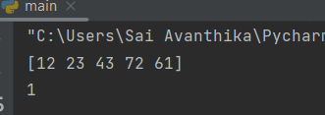

* **Two dimensional**

Two dimensional or 2-D shapes do not have any thickness and can be measured in only two faces.

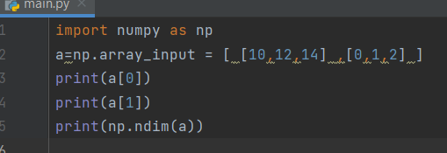

The numpy is imported as np. Array value is assigned as “a”. Each value of a is assigned with index value.The “a” is printed and the dimension of array if found using np.ndim() function.

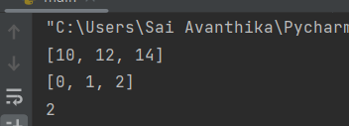

* **Three dimensional**

Three-dimensional shapes are solid figures or objects .Three-dimensional shapes have thickness or depth.

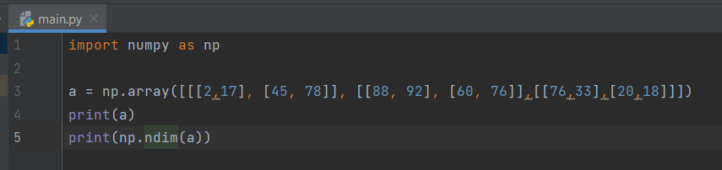

The numpy is imported as np. Array value is assigned as “a” .The “a” is printed and the dimension of array if found using np.ndim() function.

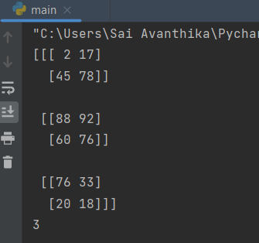

**Hard problem:**

**Starting with a 1-indexed array of zeros and a list of operations, for each operation add a value to each the array element between two given indices, inclusive. Once all operations have been performed, return the maximum value in the array**

**Solution:**

* The size of array and number of operation is given as input.
* Queries array for the left index a, right index b and summand k.
* arrayManipulation() function is defined.
* Initial array of size n with values 0 is created.
* The arr array is summed with k value from index a to b of that array, for every query
* The maximum value of arr array is printed and returned

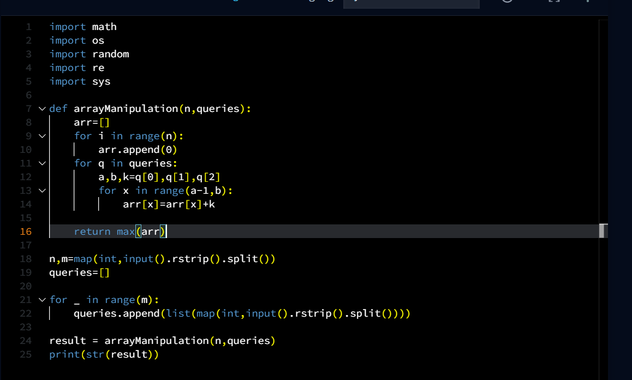

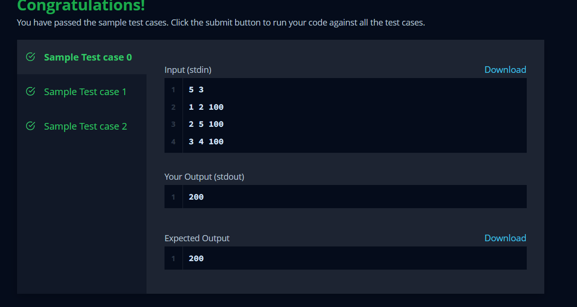

SAI AVANTHIKA K

III YR